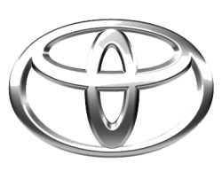
TOYOTA
TOYOTA MOTOR CORPORATION
I. TOYOTA-CHO TOYOTA. AICHI, 471—8571(HEAD OFFICE)
or 471 8572 (Research 5 Development Group) THAILAND
TEL: +81-565-28-212

GSO Conformity Certificate CCR No. 995050
Motor Vehicles
Manufacturer: Toyota Motor Corporation
Country of Origin: THAILAND, Country of Production: THAILAND
To: GCC Standardization Organization (GSO)
We hereby certify that the vehicles manufactured by Toyota Motor Corporation
* Type: TOYOTA HILUX (GUN126) 2.8L Pick-up 4WD 4Doors
* VlN number: MR0BA8CD7T0207686
* Model Year: 2026 * Produced in and after: Month 02 Year 2026
* Category: Truck
Will satisfy the G50 Technical Regulations Nos: 34:20o7, 3s:2007, 36:2005, 37:2012, 38:200s, 392005, 40:2011,42:2015, 48:1984, 51:20o7, 52:2007, 53.2007, 9611988. 9721988, 9811988, 9921988,13522007, 13622007. 29021994. 4119:1994,42o:1994,421:2005,422:200s.1040:20001041:2000,1042:2000,1053:2000,1503:2010,1598:2002,1624:2002,1677:2003,1708:2o0s,1780:2010,1781:2006,1782:2008,1783:2006,1784:2o0e.Gsolso1585:2008,GSO lSO 3537:2008, GSO 150 3538:1997, G50 ECE13H:2012,GSO ECE13H-1:2012,GSO ECE13H-2:2012,GSO ECE 13H-3:2012, GSO ECE13H-4:20l2, GSO ECE13H-S:2012,GSO ECE 13H-6:2012 and the standards in the country of origin accepted by GSO in the case that no GSO technical regulations and standards are available.
All the essential technical data are as follows:
1. Weights
a. Maximum Vehicle Weight: 2910 kg b. Curb: 2015 kg
c. Maximum Axle Weight: Front: 1400 kg Rear: 1650 kg
2. Dimensions
a. Length: 5325 mm b. Width: 1900 mm
c. Height: 1815 mm d. Wheelbase (Fl R1) 3085 mm e. Track: Front: 1540 mm Rear: 1550 mm
3. Type of chassis and body: Body-on-frame
4. Number of Passengers: 5(Including the Driver)
5.Engine: Diesel a. Cylinders: 4 b. Displacement: 2755cc c. Air intake: Naturally Aspirated
d. Net Engine Power: 150 kW at 3400 rpm Pollutant Limit comply with Euro 4.
6. Transmission: Automatic
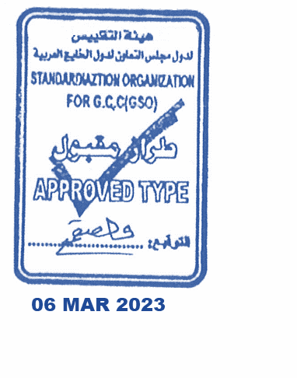
7. Brakes a. Service Brakes: Hydraulic b. Emergency Brakes: Combined with the service brake
8. Fuel Economy a. Motor Vehicle Class: Light Truck b. FE (CAFE) Combined: 15.1 km/L - Excellent
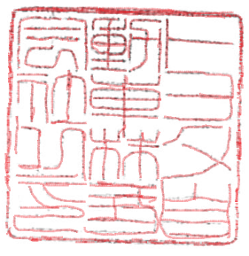
9. Any other information or local standards to be compiled: Also comply with the National regulations for member countries mentioned in the Annex of the list of Technical Regulations for MV 2026 MY-D5, when exporting to those countries.
Keiko Yanagi
general Manager Regulation &Certiﬁcation Division
4 MAR 2026 20262025

